FOR IMMEDIATE RELEASE:

California Girls Skateboards Launches World’s First Line Of Bikini Model Skateboards

A first in the skateboarding industry, California Girls Skateboards has released a line of over a dozen skateboards, featuring actual photographs of bikini models as the graphics on the boards.

LOS ANGELES, California - 7 May 2009 - Photographed entirely in California and independently produced by Eric Muss-Barnes, avid skateboarder and artist, California Girls Skateboards is a new skateboard line which showcases swimwear models as the underside graphics. Unlike traditional skateboards, which have always been printed using silk-screened illustrations; California Girls Skateboards have actual photos baked to the 7-ply North American Maple hardwood, using high-pressure thermal printing technology.
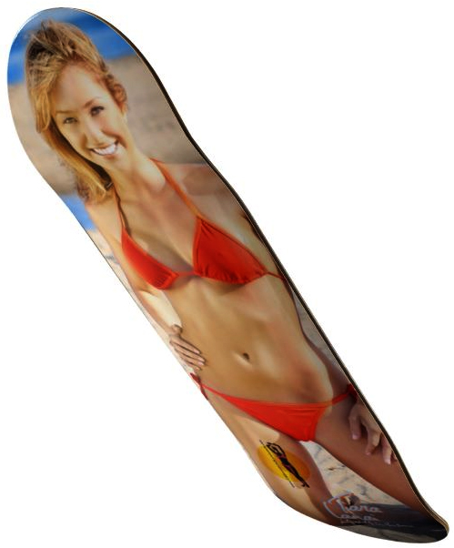
Available exclusively online, at www.CaliforniaGirlsSkateboards.com, every single California Girls Skateboards photo can be purchased on the customers’ choice of 8 different styles of boards – from modern sizes reflecting the latest trends, to “old school” 1970s style decks. Breaking the mold of traditional skateboards, where the artwork is only available in a single size, with California Girls Skateboards decks, the rider can customize his or her board with the exact graphic they want, on a board with the precise dimensions they enjoy most.

Although there have been small runs featuring models on a few independently produced skateboards, the lineup from California Girls Skateboards marks the first time a major line of over a dozen skateboards have been planned, designed, and created from scratch, featuring wholesome and fun-loving images of some of the prettiest swimsuit models in California. Each and every image was photographed exclusively for California Girls Skateboards by Eric Muss-Barnes, and appears nowhere else.

“When I came up with the idea to create California Girls Skateboards, I immediately knew I wanted it to be a very dignified and tasteful project,” explains Muss-Barnes. “I like to think my late conservative grandmother might even find my bikini girls tasteful… or at least tolerable.” Muss-Barnes adds with a laugh.

"As I did my research, I discovered no one has ever done anything like this before; although, a few companies had released limited-edition runs of 3 or 4 boards with similar graphics, but nothing as large as this. I also made a concerted effort to find beautiful models with some decorum. I wanted respectable girls who exhibit grace and class, along with being amazing-looking; the wholesome girl-next-door. They are coy and flirtatious, but never crass."

- MORE -

In keeping with the notion of portraying each girl in the best possible light, every model has a profile page and a short video on the California Girls Skateboards website.

Elaborating on the videos, Muss-Barnes explains, “The video aspect of California Girls Skateboards was very important to me, because I wanted to show the personality of my girls. These photo sessions are such a blast, and I wanted people to see the girls being silly and laughing and understanding what a genuinely good time we have while taking these pictures. There may be a lot of hard work going into it, but it’s all in the name of having fun.”

Inspired by the funloving surfer girls of the 1960s beach scene, plus the fluorescent styling of 1980s skateboarding, Muss-Barnes single-handedly designed and built everything from the layout and programming of the California Girls Skateboards website, to the graphical elements of the skateboards themselves; portraying a stylish mix between minimalist trends of modern graphic arts aesthetics, and the neon flashiness prevalent in 1987.

“In designing the look and feel of the website, I kept thinking of the Beach Boys California Girls and David Lee Roth doing the remake in the 80s,” Muss-Barnes says. “That indelible image of California girls simply hasn’t changed for decades. I want everything I do with California Girls Skateboards to reflect that ideal of beaches and skating and sunshine. I just want to give a kid back in Ohio the chance to hold a small piece of that California dream in his hands, like I used to with my skateboards… except my boards never had gorgeous bikini girls on them! That would have been so much better!”

In addition to skateboards, customers can buy an enormous array of California Girls Skateboards merchandise - including posters, stickers and clothing - all available on the website. Fully customizable apparel permits men’s, ladies and kids shirts, jackets and sweatshirts to be made-to-order in endless color and style combinations. Just like every skateboard can be ordered in 8 different sizes, a single t-shirt graphic can be purchased on hundreds of garment permutations.

Providing the best possible shopping experience, the world-class customer service teams for California Girls Skateboards also represent household namebrands such as Disney®, Barbie®, Looney Tunes® and Star Wars™; along with the likes of The Library of Congress, The Humane Society and March of Dimes. With client satisfaction a top-priority, the California Girls Skateboards customer service teams are experienced in assisting some of the most highly respected organizations in the world.

For additional information on California Girls Skateboards, contact Eric Muss-Barnes. California Girls Skateboards can be ordered online at: www.CaliforniaGirlsSkateboards.com

CONTACT:

Eric Muss-Barnes
sales@CaliforniaGirlsSkateboards.com
http://www.CaliforniaGirlsSkateboards.com

###

